ASSIGNMENT OF HTML

**Q1- ARETHE HTML TAGSANDELEMENTS THESAMETHING?**

**ANS- NO HTML TAGS AND ELEMENTS ARE DIFFRENT THING.**

**\***HTML TagsAre Used To Hold The HTML Element.

HTML ELEMENT HOLDS THEE CONTENT. HTML ATTRIBUTES ARE USED DESCRIBE THE CHARAACTRISTIC OF AN HTML ELEMENT IN DETAIL.

* **TAGS:-**

a piece of markup language used to indicate the beginning and end of an HTML element in an HTML document

* **ELEMENTS:-**

a component of an HTML document that tells a web browser how to structure and interpret a part of the HTML document.

* EXAMPLE:

1. <!DOCTYPE> Defines the document type

2 .<html> Defines an HTML document

3 .<head> Contains metadata/information for the document

4 .<title> Defines a title for the document

5.<body> Defines the document's body

6.<h1> to <h6> Defines HTML headings

7.<p> Defines a paragraph

8.<br> Inserts a single line break

**Q2- WHAT ARE TAGS AND ATTRIBUTES IN HTML?**

**TAGS**

**ANS-** HTML tags are simple instruction that tell a web browser how to format taxt you can use tags to format italics, line breaks, objects, bullet points and more.

**ATTRIBUTES**

**\*** a piece of markup language used to adjust the behaviour Or display of an html elements.

**EXAMPLE OF TAGS**

<h1>abcd</h1>

<p>abcd</p>

<b>abcd</b>

<u>abcd</u>

**Q3- WHAT ARE VOID ELEMENTS IN HTML? WITH EXAMPLE.**

**ANS-** HTML elements which do not have closing tags

Or do not need to be closed are void elements.

**EXAMPLE OF VOID ELEMENTS IN HTML**

**<br> tags**

**<img> tags**

**<hr> tags**

**<link> tags**

**<meta> tags**

**Q4- WHAT ARE HTML ENTITES ? WITH EXAMPLE**

**ANS- html entities means in html some character are reserved like ‘<’,**

**‘>’ etc.to use these characters in our webpage we need to use**

**The character entities called html entities .below are a few**

**Mapping between the reserved character and its respective**

**Entity character to be used.**

|  |  |  |  |  |
| --- | --- | --- | --- | --- |
| < | less than | &lt; | &#60; | [Try it »](https://www.w3schools.com/html/tryit.asp?filename=tryhtml_ent_lt) |
| > | greater than | &gt; | &#62; | [Try it »](https://www.w3schools.com/html/tryit.asp?filename=tryhtml_ent_gt) |
| & | Ampersand | &amp; | &#38; | [Try it »](https://www.w3schools.com/html/tryit.asp?filename=tryhtml_ent_amp) |
| " | double quotation mark | &quot; | &#34; | [Try it »](https://www.w3schools.com/html/tryit.asp?filename=tryhtml_ent_quot) |
| ' | single quotation mark (apostrophe) | &apos; | &#39; | [Try it »](https://www.w3schools.com/html/tryit.asp?filename=tryhtml_ent_apos) |
| ¢ | Cent | &cent; | &#162; | [Try it »](https://www.w3schools.com/html/tryit.asp?filename=tryhtml_ent_cent) |
| £ | Pound | &pound; | &#163; | [Try it »](https://www.w3schools.com/html/tryit.asp?filename=tryhtml_ent_pound) |
| ¥ | Yen | &yen; | &#165; | [Try it »](https://www.w3schools.com/html/tryit.asp?filename=tryhtml_ent_yen) |
| € | Euro | &euro; | &#8364; |  |

**Q5- WHAT ARE DIFFERENT TYPES OF LISTS IN HTML? With EXAMPLE**

**ANS-** there are 3 type of lists in html

1. **ORDER LIST**
2. **UNORDER LIST**
3. **DIFINE LIST**

**ORDER LIST**

Order list means defines a list of item in which the order of

The items are matters

5 types in oreder list

**UNORDER LIST**

Unorderlist means a list whose order is not important, and as such does not use number or letters to order them, instead

Displaying bullets to mark individual items.

3 types in unorder list

**DIFINE LIST**

Difine list means a list of terms , with a description of each

Term.

**EXAMPLE OF ORDER LISTS**

<ol>

<li>xyz</li>

<li>abd</li>

</ol>

<ul>

<li>abc</li>

<li>xyz</li>

<dl>

<dt>abc</dt>

<dd>xyz</dd>

</dl>

**Q6- WHAT IS THE ‘CLASS’ ATTRIBUTE IN HTML? WITH EXAMPLE**

*ANS-* the class attribute is used to specify the class name for an

Html elements .multiple elements in html can have the same

Class value .also , it is mainly used to associate the styles

Written in the stylesheet with the html

* **EXAMPLE OF CLASS ATTRIBUTE**

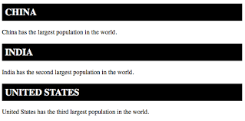

**Q7- WHAT IS THE DIFFERENT BETWEEN THE ‘ID’ ATTRIBUTE AND THE**

**‘CLASS’ ATTRIBUTE OF HTML ELEMENTS ? WITH EXAMPLE**

**ANS-** multiple elements in HTML can have the same class value

Whereas a value of id attribute of one element cannot be

Associated with another HTML elements

* **DEFINATION OF CLASS ATTRIBUTE**

The class attribute specifies one or more classnames for

an element.

* **DEFINATION OF ID ATTRIBUTE**

The id attribute specifies a unique id for an HTML element

* **EXAMPLE OF ID ATTRIBUTE**

<html>  
<body>  
  
<h1 id="myHeader">Hello World!</h1>  
<button onclick="displayResult()">Change text</button>

* **EXAMPLE OF CLASS ATTRIBUE**

<div class="city">  
  <h2>London</h2>  
  <p>London is the capital of England.</p>  
</div>  
  
<div class="city">  
  <h2>Paris</h2>  
  <p>Paris is the capital of France.</p>  
</div>

**Q8- WHAT ARE THE VARIOUS FORMATTING TAGS IN HTML?**

**ANS-** HTML has various formatting tags

* **<b>** makes text bold
* **<i>** makes text italic
* **<em>** makes text itelic but with added semantics importance
* **<big>** increase the font size of the text by one unit
* **<strong>**marks the text a superscript
* **<sup>** makes the text a subscript
* **<sub>** makes the text a subscript

**Q9- How is Cell Padding different from Cell Spacing? With Example.**

**ANS-** cell spacing is the space or gap beetween two consecutive cells.

Whereas , cell padding is the space or gap beetween the next

Content of the cell and the edge border of the cell.

* **EXAMPLE OF CELL PADDING AND CELL SPACING**

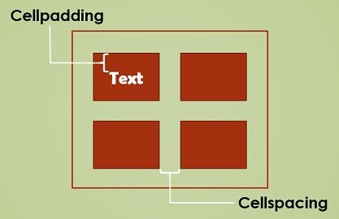

**Q10- HOW CAN WE CLUB TWO OR MORE ROWS OR COLUMNS INTO**

**A SINGLE ROW OR COLUM IN AN HTML TABLE?**

**ANS-** html provied two tables attribute “rowspan” and ”colspan” to

Make a cell span to multiple rows and columns respectively

**Q11- WHAT IS THE DIFFRENCE BETWEEN A BLOCK – LEVEL ELEMENT AND AN INLINE ELEMENT?**

**ANS-** blocl – level elements means a always starts on a new line , and

thebrosers automatically add some space ( a margin) before and after the elements

in line element means does not start on a new line it only takes up as much as necessary

**Q12- HOW TO CREATE A HYPERLINK IN HTML ? WITH EXAMPLE**

**ANS-**  html links are hyperlinks ..

You can click on a link and jump to another document. When you

Move the mouse over a link, the mouse arrow will turn into a little

Bond..

to make a hyperlink in an HTML page.

**USE THE <a> AND </a> tags**

Anchor tag use for create a hyperlink

* **EXAMPLE OF HYPERLINK**

**<a href = “ url” > link text </a>**

**Q13- WHAT IS THE USE OF AN I FRAME TAG? WITH EXAMPLE**

**ANS-** I frame means an inline frame (I frame) is a html element

That loads another html page within the document.

It essentially puts another webpage within the parents

Page.

**THEY ARE COMMONLY USED FOR**

* **ADVERTISEMENT**
* **EMBEDDED**
* **VIDEO**
* **WEB ANALTICS**
* **AND INTERACTIVE**

**Q14- WHAT IS THE USE OF SPAN TAG? EXPLAN WITH EXAMPLE ?**

**ANS-** span tag means the span tag is a generic inline container elements. To wrap section of text for styling purpose or

To add attribute to a section of text without creating a new

Line of content

**EXAMPLE OF SPAN TAG**

MY NAME IS <span> ADARSH</span>

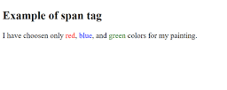

Q15- **HOW TO INSERT A PICTURE INTO A BACKGROUND IMAGE OF** **A WEB PAGE? WITH EXAMPLE**

ANS- the easiest method to add a background attribute in the

<body> tag in html

**<h style = “ background– image: url ( ‘ img_bike.jpg’) ;” >**

**EXAMPLE OF INSERT BACKGROUND IMAGE**

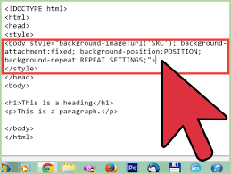

**Q16- HOW ARE ACTIVE LINKS DIFFERENT FROM NORMAL LINKS?**

**ANS-** normal link means links are which are there on the page and have not been clicked yet.

Active link means link are those links which have just been

Clicked at the instant. And active link also blue color link

**EXAMPLE OF ACTIVE AND DIFFERENT LINK**

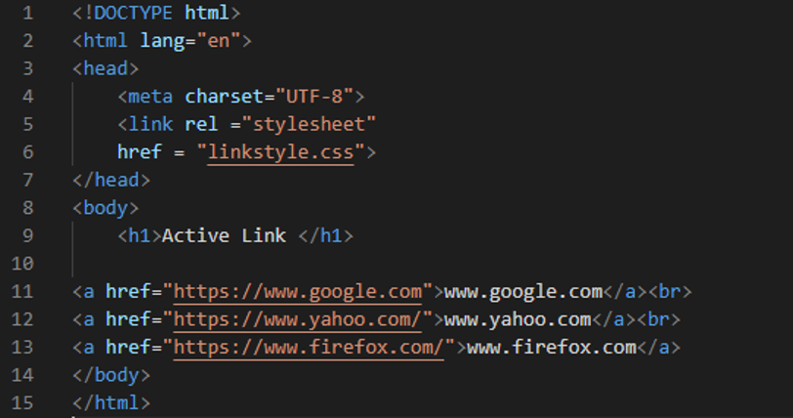

**Q17- WHAT ARE THE DIFFERENT TAGS TO SEPRATE SECTION OF TEXT?**

**ANS-** three tags are use in sepret tags

* **<p> tag**
* **<br> tag**
* **<blackquote>**

<p> tag – this tag is used to write a paragraph of text

<br> tag- it is used to seprate the line of text it breaks

The current line and shift the flow of the text to a new line

<blackquote> tag – this tag is used to define large quoted section.

**Q18-** **WHAT IS SVG?**

**ANS-** SVG full form means **scalable vector graphics** is

Svg means displaying two dimensional graphics

Charts, and illustration on websites

**Shape of svg**

* **A RECTANGLE**
* **A LINE**
* **A POLLY**
* **TWO ELLISCAPY**
* **A STAR**
* **ANOTHER STAR**

**EXAMPLE OF SVG**

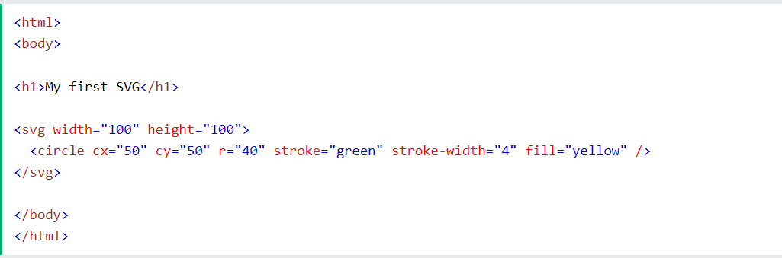

**Q19- WHAT IS THE DIFFERENT BETWEEN HTML AND XHTML**

**ANS-** the main difference between them is the syntax and structure html is more lenient in its syntax while

Xhtml has a more strict syntax and follows xml rules

Html is sgml based whereas xhtml is an xml based language

HTML stands for hypertext markup language

**XHTML stands for extensible hypertaxmarkup language**

The formate is a document file format

**XHTML is0a markup language format**

**Q20- WHAT ARE LOGICAL AND PHYSICAL TAGS IN HTML?**

**ANS-** The HTML the formatting tags are divided into two

Categories

**PHYSICAL TAG:-.**

These tags are used to provide the visual appearance

To the text.

**LOGICAL TAG:-**

These tags are used to add some logical or semantic

Value to the text

**PHYSICAL TAGS**

* Underline <u> and </u>
* Italic <i> and <i>
* Boldface <b> and </b>

**LOGICAL TAGS**

* <abbr>
* <cite>
* <del>
* <dfn>
* <address>